Google Earth architectural design scavenger hunt

You are to locate and snap pictures of 2 examples of the following type of structures within Google Earth. The pictures must be of 3D models and taken from within Google Earth to count. Paste both images into the following table and type the name of the structure and it’s location below it (Don’t forget to format your images).
Example:
- Professional Basketball Arenas
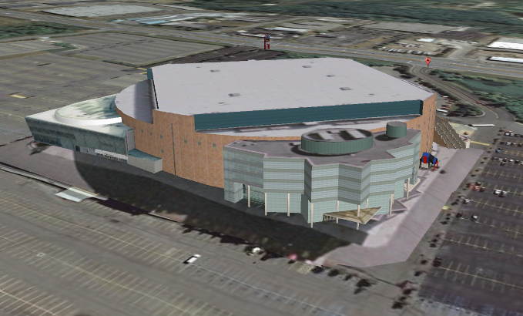 |  | 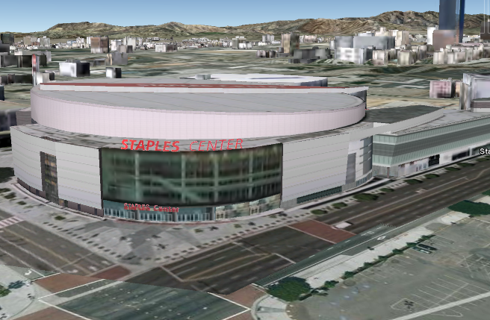
Structure / Building Name | Palace of Auburn Hills | Structure / Building Name | Staples Center
Location | Auburn Hills, MI | Location | Los Angeles, CA

- Famous Cathedrals / Churches
Structure / Building Name |  | Structure / Building Name
Location |  | Location

- Famous Towers
Structure / Building Name |  | Structure / Building Name
Location |  | Location

- Famous Bridges

Structure / Building Name |  | Structure / Building Name
Location |  | Location

- Famous Museums
Structure / Building Name |  | Structure / Building Name
Location |  | Location

- Professional Football & Baseball Stadiums (1 of each)
Structure / Building Name |  | Structure / Building Name
Location |  | Location

- United States Government Buildings
Structure / Building Name |  | Structure / Building Name
Location |  | Location

- Famous Statues
Structure / Building Name |  | Structure / Building Name
Location |  | Location

